Wednesday 4th March 2026

Dear Parents/Carers,
Eid – Thursday 19th March / Friday 20th March
I am writing to inform you that the school may be partially closed to pupils on either Thursday 19th March or Friday 20th March due to Eid ul-Fitr.
We endeavour to keep the school open, if possible; however, due to many of our staff celebrating Eid, the pupil-to-staff ratio may not be safe to fully open to all pupils. We expect to be in a position to make a decision and communicate this to parents on Wednesday 18th March.
Based on information from previous Eid celebrations, we are able to offer up to 40 places to families with extenuating circumstances.
Should we need to close the school, and you feel that your child needs to attend, please complete the Microsoft Forms link that will be shared on Class Dojo and via email by Wednesday 11th March. From this information, we will ascertain which pupils can be allocated a place and will inform parents by Monday 16th March. Please note that completing the form does not guarantee your child a place in school; however, we will endeavour to support families where possible.
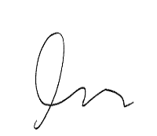
Yours sincerely,

Patrick Jones
Headteacher

